Program 9
Develop a JavaScript Event Handling mechanism to change the background colour of an HTML page.

eventHandling2.html:
<html>
<head>
<title>program 9</title>
<style>
body {
text-align: center;
}
h1 {
font-size: 32px;
color: #2c3e50;
margin-top: 20px;
letter-spacing: 1px;
}
h2 {
font-size: 22px;
color: #34495e;
margin-bottom: 20px;
font-weight: normal;
}
#btn {
background-color: #4CAF50;
color: white;
border: none;
padding: 12px 30px;
font-size: 18px;
border-radius: 6px;
cursor: pointer;
}
</style>
</head>
<body id="bc">
<h1>JAVASCRIPT EVENT HANDLING</h1><br>
<h2>Background Color Change</h2>
<button id="btn">change Color</button>
<script>
var x = document.getElementById("btn");
var bcColor = document.getElementById("bc");

x.addEventListener("click", func1);

function func1() {
x.style.backgroundColor = 'blue';
bcColor.style.backgroundColor = 'red';
}
</script>
</body>
</html>

OUTPUT:
Before Event:
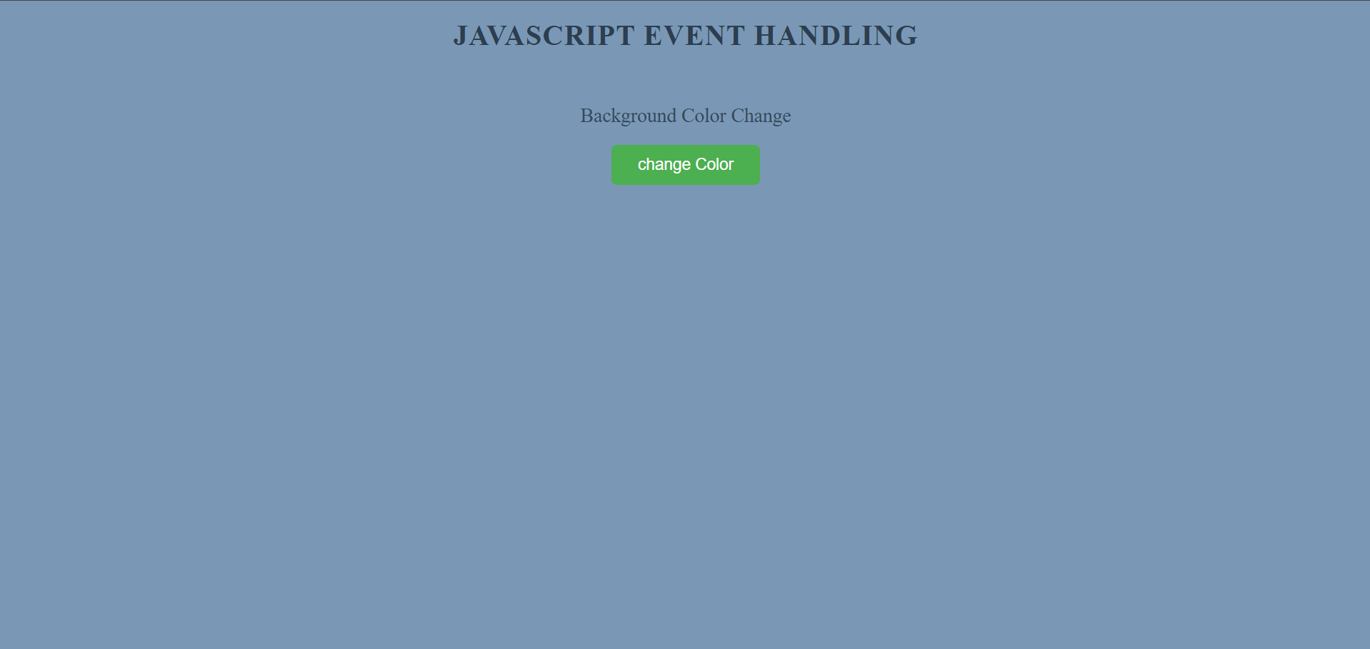

After event:
